

Poll: Nearly half of Americans think the economy is doing well

BY BRETT SAMUELS / March 12, 2018, 7:37 AM



Just less than half of Americans believe the economy is doing well under President Trump, a new poll shows.

A CBS News Poll, released Sunday, found that 48 percent of Americans say the country is doing well economically, compared to 22 percent who say it’s doing poorly. Another 30 percent said it is neither doing well or poorly, according to the poll.

*Just under 50% of Americans believe the economy is doing well. Source: CBS News Poll, March 9-11, 2018.*

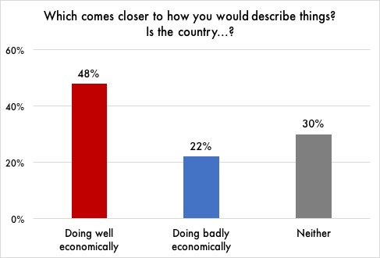

Another 49 percent of respondents indicated they believe the U.S. is run for the benefit of a few elites. By comparison, 28 percent said they believe the country is run for the benefit of the people, while 22 percent said neither, according to the poll, which was conducted Feb. 10-12. The poll had 2,164 respondents and has a margin of error of 2.6 percentage points.

President Trump has frequently touted the economy’s performance under his administration, often tweeting out reports of the stock market hitting new highs. The White House has also balked at suggestions that former President Obama is responsible for the current state of the economy.

A recent Quinnipiac poll showed 49 percent of respondents gave Obama credit for the current economy, compared to 40 percent who gave Trump credit.